Spike: 1
Title: GridWorld

Author: Rachel McQueenie, 696737X

Goals / deliverables:
- A simple console/Command Line Interface (CLI) game named 'GridWorld,' which makes use of the simple game loop, as well as separation of update, render and input code.
- Paper-based design of the code

Technologies, Tools, and Resources used:
- Visual Studio 2012
- Windows 8

Tasks undertaken:
- Designed the solution on paper, which can be seen in Appendix 1.
- Downloaded and installed Visual Studio 2012
- Created a new C++ project
- Added a new .cpp file to the project
- Set up the grid
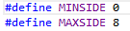

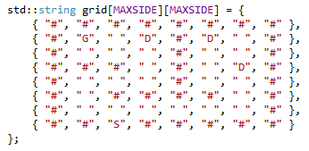

- Set up the user input.
  - Check for the boundaries of the grid
  - Check if the space the player is going to move onto is a wall
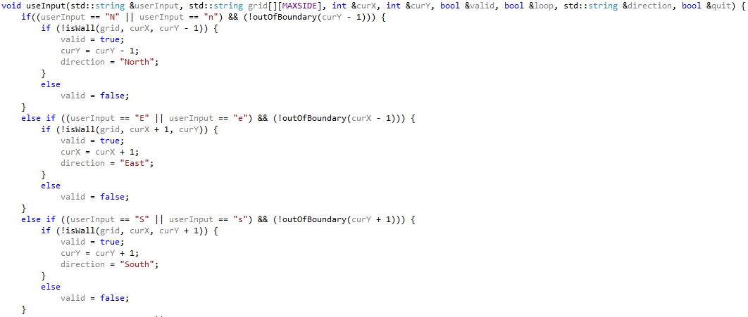

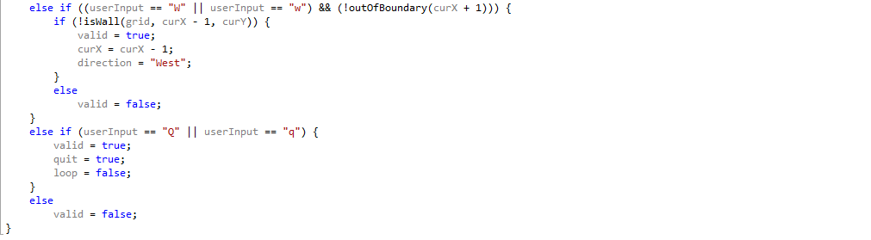
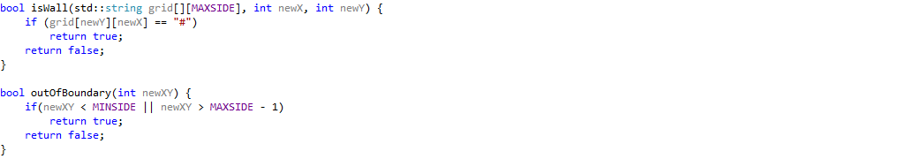
- Set up the update function
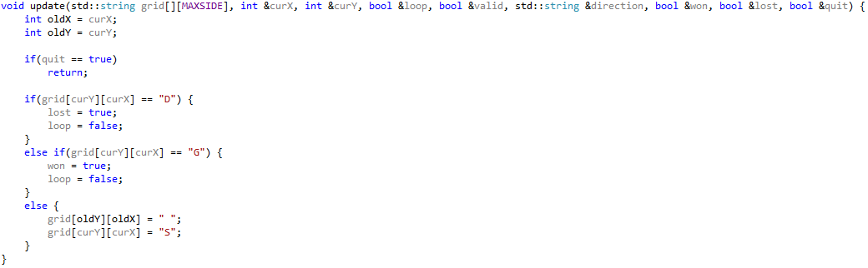
- Set up the rendering code
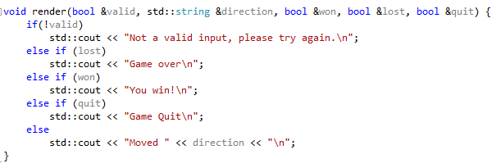
- Set up the main game loop and data required for the game
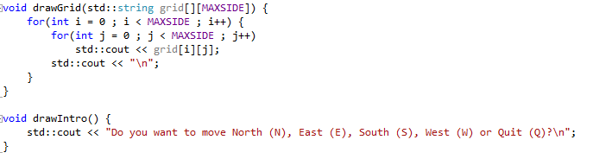
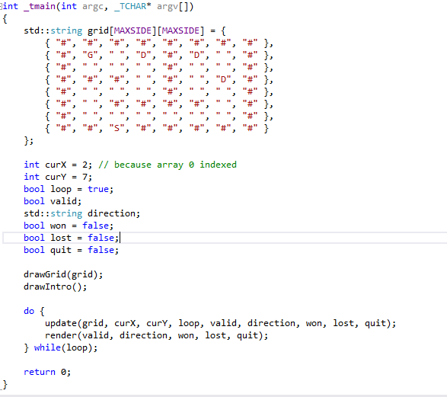
What we found out:
The game loop is a simple and useful tool in game programming as it allows the application to run smoothly regardless of user input, as several computations need to be made around user, such as moving enemies and AI calculations. This, however, would not be a good option for certain other applications, such as a word processor where nothing needs to be done until the user inputs something.
Appendix:
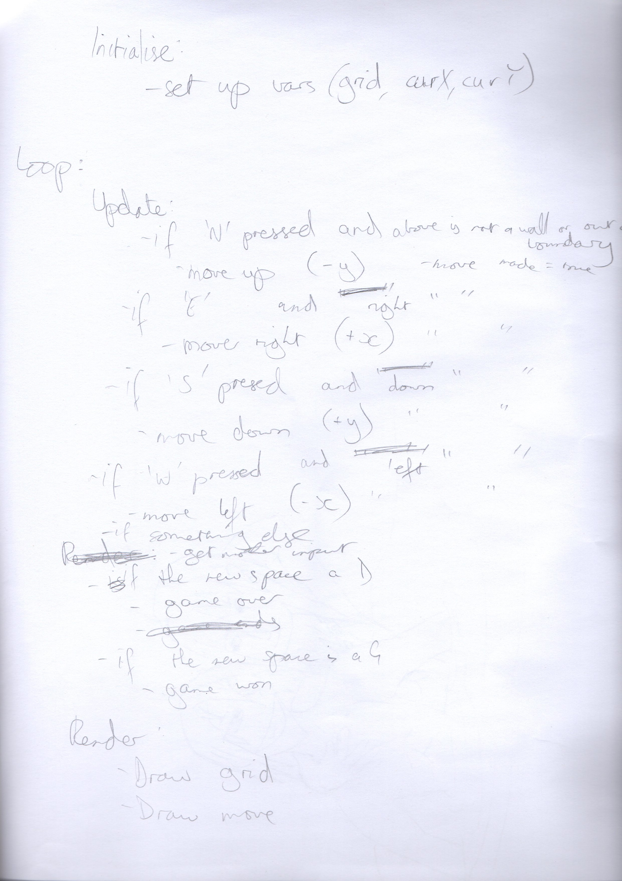
Appendix 1

